John Redmond – RIP

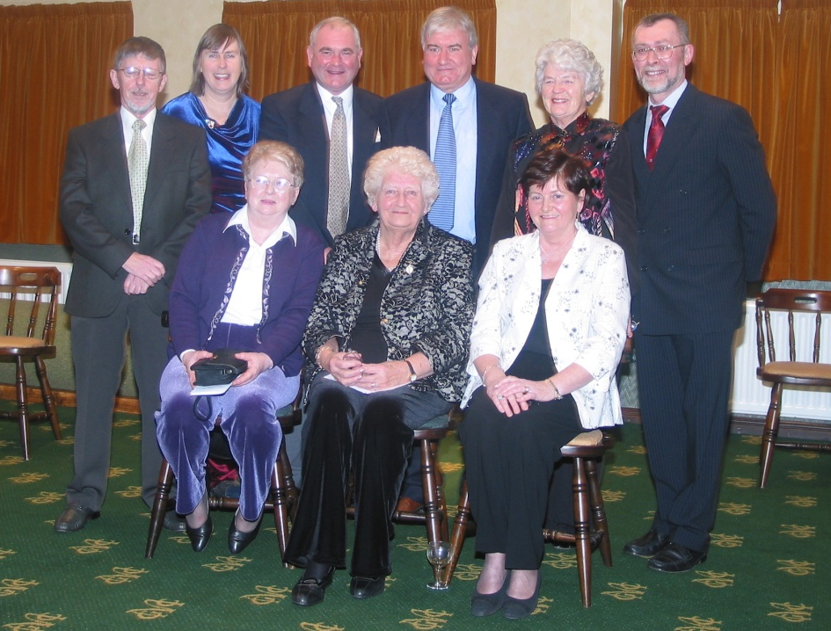
Photograph taken of the Committee in 2004 at 60th Anniversary of Newcastle Bridge Club. A dapper John Redmond on the extreme right, that’s how we will remember him.

John passed away on Monday 30th March.
His funeral service will take place at 10.00 on Friday 3rd April in Our Lady of the Assumption Church in Newcastle. Since no one is allowed to attend this service you can watch it live streamed on https://www.mcnmedia.tv/camera/our-lady-of-the-assumption-church-newcastle or https://www.facebook.com/ParishofMagheraDC/. His body will be cremated at 2.00 on Saturday and we ask all members to light a candle and observe a minute’s silence at this time. His ashes will be scattered at a later date, after we all allowed to gather together, when the family will organise a memorial service.

He joined the Newcastle Bridge Club in 1994 after playing for many years in London and elsewhere. He very quickly became one of the clubs leading lights, joining the committee, directing tournaments and helping with teaching beginners. He won the Thomason salver for the top player of the year in 2003, 2008, 2009, 2015 and 2016. His name also appears multiple times on all our other trophies.

Here are some of the memories of John sent in by his friends.

“John a man of many talents. In the early days in the Bridge Club he revelled in organising directing and supervising play. All with a confidence and constancy which settled us all down and enabled a smooth enjoyable evening of Bridge. Sometimes the Club held its breath if John was late coming from work as he was the chief leader and organiser. However, he did always make it and when he appeared in his dark work suit everyone breathed a sigh of relief knowing it would be ok and Bridge would start on time.”

“On a more recent evening a new member delighted in calling him ‘the Master’.”

“There were few better players. John was the life and soul of the Club for many years and will be remembered with fondness by all.”

“I have played against many skilled opponents in my bridge history and he was among the most skilled. He seemed to assess (from the bidding) the quality and shape of all the hands at the table. His course of action was decisive- and indeed incisive for those chancing their arm! However, he never had a superior attitude and would give praise for well-played hands ----even when it was giving him a low score.”

“He told us one night, between games, that his love of bridge developed when he played with colleagues, in London. There he honed the skills which he later brought to the Newcastle Bridge club. He became a very efficient Secretary for many years. John also facilitated the lovers of bridge by running summer bridge in the Annesley Hall. As well as this, he was part of a dedicated team who teach bridge to interested learners. He certainly played his part to ensure the growth and vibrancy of the Newcastle and the Mourne Bridge clubs.”

“There was more to John than Bridge. He was loyal and kind. He quietly and regularly visited a former bridge partner, who was by that time in a nursing home. I remember at Bridge someone, giving him information, told him to put it on his phone. He replied that he had lent his phone to the lady in the home because she had misplaced her own. These days how many would do that?”

“John was also very loyal to Bridge friends who had lost a loved one. He was always at funeral services to give support to the bereaved. John cared about people.”

I’ll leave you with John’s words after he had a successful evening with you “Well done, I’ll play with you anytime.”

