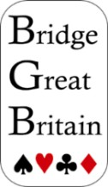

The 2026
Lady Milne Trophy
hosted by the
Northern Ireland
Bridge Union
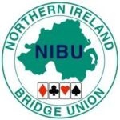

LA MON HOTEL & COUNTRY CLUB
Belfast
17 - 19 April 2026
2026 Lady Milne Trophy
The Northern Ireland Bridge Union extends a very warm welcome to all the teams participating in the 2026 Lady Milne Trophy.

Officials:
Match Manager Brian Mullan
Director in Charge Fergal O’Brien
Assistant Directors Mairead Basquille

RealBridge Broadcasting Team
(Stuart King) and a cast of volunteers. Thanks also to Shireen Mohandes and Andy Bowles of RealBridge.

Refreshments
Refreshments for players and officials will be served in the Mornington Restaurant at the following times:
Friday 17:30 Buffet Meal
Saturday 14:35 Light Lunch 20:15 Dinner
Sunday 14:35 Light Lunch
20:00 Reception and Dinner (sit down 20:15)

Friday | 17.30 | Buffet meal
 | 19.00–21.10 | D v F | C v E | B v A
 | 21.25–23.35 | D v F | C v E | B v A
Saturday | 10.00–12.10 | A v C | B v D | F v E
 | 12.25–14.35 | A v C | B v D | F v E
 | Lunch
 | 15.20–17.30 | E v A | F v B | C v D
 | 17.45–19.55 | E v A | F v B | C v D
 | 20.15 | Dinner (sit down at 20.15)
Sunday | 10.00–12.10 | B v C | A v F | E v D
 | 12.25–14.35 | B v C | A v F | E v D
 | Lunch
 | 15.20–17.30 | F v C | E v B | D v A
 | 17.45–19.55 | F v C | E v B | D v A
 | 20.15 | Closing Dinner (sit down at 20.15)
Team A: | England
Team B: | Ireland
Team C: | NIBU
Team D: | Scotland
Team E: | Northern Ireland
Team F: | Wales

2026 LADY MILNE TROPHY
MATCH SCHEDULE

2026 LADY MILNE TROPHY
Match Schedule
 |  | Table 1 | Table 2 | Table 3
FRIDAY
17:30 | Dinner
19:00-21.10 | Match 1A | Scotland v | NIBU v | Ireland v
 |  | Wales | Northern Ireland | England
21:25-23:35 | Match 1B | Scotland v | NIBU v | Ireland v
 |  | Wales | Northern Ireland | England
SATURDAY
10.00 - 12.10 | Match 2A | England v | Ireland v | Wales v
 |  | NIBU | Scotland | Norther Ireland
12.25 - 14.35 | Match 2B | England v | Ireland v | Wales v
 |  | NIBU | Scotland | Northern Ireland
14:35 | Lunch
15:20-17:30 | Match 3A | Northern Ireland v | Wales v | NIBU v
 |  | England | Ireland | Scotland
17:45-19:55 | Match 3B | Northern Ireland v | Wales v | NIBU v
 |  | England | Ireland | Scotland
20:30 | Dinner (sit down at 20:15)
SUNDAY
10.00 - 12.10 | Match 4A | Ireland v | England v | Northern Ireland v
 |  | NIBU | Wales | Scotland
12.25 - 14.35 | Match 4B | Ireland v | England v | Northern Ireland v
 |  | NIBU | Wales | Scotland
14:35 | Lunch
15:20-17:30 | Match 5A | Wales v | Northern Ireland v | Scotland v
 |  | NIBU | Ireland | England
17:45-19:55 | Match 5B | Wales v | Northern Ireland v | Scotland v
 |  | NIBU | Ireland | England
20:00 | Reception & Dinner (sit down at 20:15)
Each team has its own table and seats its N/S Pair there throughout. The E/W Pairs move to the table of their opponents for each match. In the first stanza, the captain of the second-named team nominates their line-up first; in the second stanza the first-named captain nominates first.
THE LADY MILNE TROPHY
Format
The Lady Milne Trophy comprises six teams, the sixth team being fielded, in rotation, by the country hosting the event. In 2026 Northern Ireland fields two teams, one as “Northern Ireland” the other as “NIBU”.
The competition sees five head-to-head matches of 32 boards in 16-board stanzas, the two teams from Ireland playing against each other in the first match.
Teams consist of a maximum of six players. Seating rights alternate between the two teams. In the first stanza the captain of the second-named team nominates their line-up first; in the second stanza the first-named captain nominates first.

Public Presentation
In any one session, three matches are in progress. The play will be broadcast on the internet via RealBridge. Entry to the Closed Room is prohibited.

Smoking and Alcohol
Please note that smoking is not permitted anywhere in the hotel. In addition, the consumption of alcohol is not permitted in the playing areas. This also applies to tournament staff. During a session no player may leave the playing area in order to smoke or consume alcohol.

Mobile Phones
Mobile phones and electronic devices capable of communication must be switched off in the playing area and be visible at the table at all times. Any player leaving the playing table prior to completion of the session must leave her mobile phone and electronic devices at the table. Spectators in the Vugraph theatre are requested to ensure that mobile phones are switched off. Any player or team official breaching this regulation will result in their team being fined an automatic penalty of 2VP.

Regulations for Open Room Spectators
You may watch the players live in the Open Room (Open Rooms will be clearly marked on the doors of each room) provided you observe the following rules:

- A spectator may not enter the Open Room while play is in progress. This also applies even if a match has started before the advertised starting time.
- If a spectator leaves the Open Room while play is in progress, they may not return until the play session (i.e. the match) has been completed.

- During play in the Open Room spectators must refrain from mannerisms or remarks and must not converse with a player or display any reaction to bidding or play.
- Spectators are permitted to observe the cards of one player only.

- A spectator should be seated behind a single player and may not get up to walk round the table or seek to look at the cards of any other player.
- Spectators are not permitted to sit where they can see the screen of the BBO operator covering the match on the internet.

- Spectators may not draw attention to any irregularity or mistake nor speak on any question except by request of the Director.
- The Director in Charge and/or the Match Manager is empowered to control the presence of spectators, individually or collectively.
- Under no circumstances may a member of the audience enter the Closed Room.

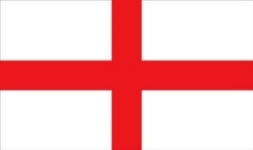 | England  Dido Coley & Lily Kearney  Helen Erichsen & Fiona Brown  Jasmine Bakhshi & Heather Bakhshi  NPC David Burn

Dido Coley & Lily Kearney
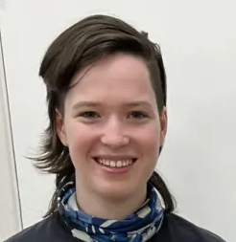
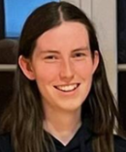
Dido learnt to play bridge properly in late 2017 when she got introduced to the U16 squad via a friend at school, and hasn't looked back since. She has gone on to play at numerous European and World Youth Championships, the most recent of which yielded a bronze medal in the Pairs Championships with partner Lily Kearney. What she lacks in age, she makes up for with complicated system, protesting that it is "fun" or something. Outside of bridge, Dido is studying Classics at Cambridge and can often be found on the river Cam at some ungodly hour.
This is Lily's debut appearance at the Lady Milne, having learnt bridge in her sixth form after chess got boring. A theoretician at heart, she learnt to code by teaching her computer to play with her. Sadly, she hasn't been able to do the same with Dido. She has a knack for tricky end positions and has devoured many a bridge book, leading to many successful beer cards (KJ7 opposite xx anyone?). When not at the table, along with a penchant for competitive quizzing and Crocs, Lily spends her time studying for her Masters in Systems Biology at Cambridge

Helen Erichsen & Fiona Brown
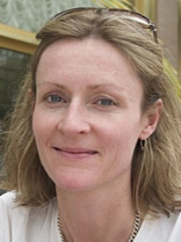
I didn’t start playing bridge until I was in my 30’s which makes it difficult to progress beyond a certain point. I make up for this deficit with good system and great partners.
I’ve had some success playing with my husband Espen Erichsen. We won gold in the European Mixed Teams in 2005 and bronze in the BAM for the same event in 2023. I know some couples struggle to play together but I always think Espen is at his most handsome when he’s just declared a tricky 3NT.
I’ve played with Fiona Brown for eight years. During that time we have been selected to play for England ten times: six Lady Milnes and four international events. There have been many highs in our partnership but the two which stand out are winning bronze at the European Women’s Pairs in 2023 and winning gold at the European Champions Cup in 2024. She is a brilliant bridge player and a very good friend.
When I’m not doing something bridge related I garden obsessively and write dark psychological thrillers. It’s a good life.
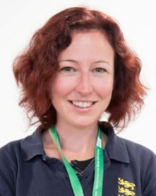
Fiona was born in Darwin, Australia and started playing when she was 10 years old. She has been a fixture in the England women's team since 2010 and has partnered Helen for eight years. They recently won the Champions Cup by 1 imp! Fiona works in IT for Bettys and Taylors of Harrogate (or Yorkshire Tea, as they are better known). She lives in South Milford with her husband Paul and much-adored cat Calcifer.

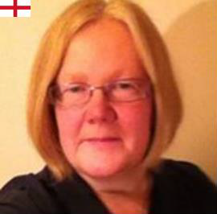
Anne Rosen & Nevena Senior
Anne learnt to play bridge in her teens in Edinburgh in the 1980s, where she played for the Scottish Junior team and won the Ladies teams, before moving south aged 22. After qualifying as a Chartered Accountant Anne moved to London to be with her now husband, Neil Rosen. Anne has recently retired and is planning to immerse herself more in art, do lots of travelling, and catching up with all her friends.
Over the years Anne has had considerable success in Ladies events and other national competitions including the Pachabo, Tollemache, Hubert Phillips and NICKO. Internationally Anne has played Ladies representative bridge with Val Curran, Gillian Fawcett, Catherine Draper, Catherine Seale, Sarah Bell, and Nevena Senior. Anne was also part of the team that won the Mind Sport Games in Beijing in 2008. Anne is looking forward to playing her 12th Lady Milne, and 5th with Nevena.
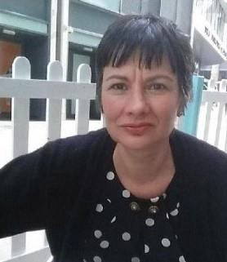
I started playing bridge during my final year at University, and my first husband introduced me to the game. I teach and play bridge both on line and face-to- face-the latter in London at Andrew Robson's BC, Wimbledon BC and the Acol club. I've won multiple medals from European and World Championships, representing Bulgaria, Great Britain and England. My best achievements are winning the European Ladies Pairs for Bulgaria in 1987, winning the European Women’s Teams for England in 2012 and 2016 and winning the World Bridge Games in 2008 and 2012 again for England. In my free time I like reading, doing crosswords, going to the gym and cooking.

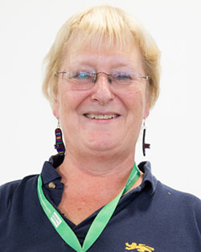
Sally Brock (NPC)

Back in the day (1979 to be precise) I played in my first European Championship, with Sandra Landy, which we won. And we won again in 1981 and also the Venice Cup that year. Between then and now I have played in and won a lot of women’s and domestic open events, including another five world championships.

Nowadays I make my living mostly by professional bridge of one sort or another: writing (I am the columnist for the Sunday Times), playing and teaching online – trying to share my passion (obsession maybe!) for the game with others!

 | Ireland  Ann-Marie Horan & Hilary D-L McDonagh  Rebecca Brown & Gilda Pender  Joan Kenny & Jeannie Fitzgerald  NPC Paul Porteous
Joan Kenny & Jeannie Fitzgerald
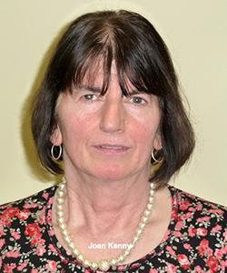
Joan is a retired Maths teacher from Headford, County Galway, who would still be very happy to “pull a pint” for any visitors to Galway in the family licensed premises – thus doing her bit for the returning diaspora! Joan is a veteran of many previous Lady Milne teams, the majority in partnership with Teresa Rigney, and four times previously with this year’s partner, and has also played on numerous European and World Championship teams.

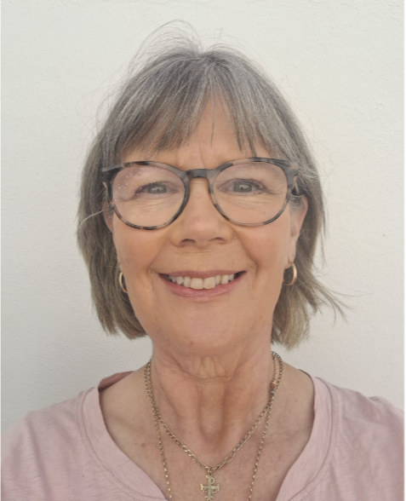
Jeannie, living in Ennis, County Clare, is involved in technology research and development, specializing in applied Artificial Intelligence. She has won many representative caps in the Lady Milne, and at European and World level, including previous partnerships with Ena Cleary and Emer Joyce. She and Joan have featured in the Lady Milne four times, and represented Ireland in the European National Teams Championships in Madeira in 2022 and Herning in 2024 and World Bridge Games in Buenos Aires 2024.

Ann-Marie Horan & Hilary D-L McDonagh
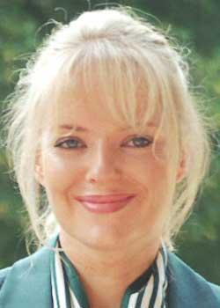
Ann-Marie is returning to international bridge after some time off to raise her family (in conjunction with her husband, Irish Open Team star John Carroll). She somehow also has time to run a very busy pharmacy. Ann-Marie has represented Ireland in three previous Lady Milnes, and also two European Championships.
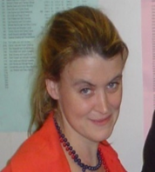
Hilary is a psychology lecturer, bridge teacher, and worked for the CBAI at National Headquarters before moving west to Ballaghadereen to raise her family. She has represented Ireland extensively at junior level and at numerous European women’s events. She achieved great success initially with Rebecca O’Keeffe winning every Irish women’s title and many open honours, and then developed a strong partnership with Anne-Marie Horan with whom she played on three Lady Milne teams. Hilary has a total of nine previous Lady Milnes and seven European or World Championships.

Rebecca Brown & Gilda Pender
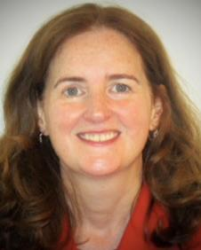
Gilda is a financial services executive spanning strategy, operations and technology. This is Gilda’s sixth Lady Milne outing, having previously played with her sister, Noreen, Hilary McDonagh, and current partner Rebecca. Gilda also has nine European and World Championship caps.

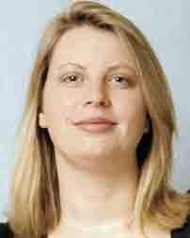
Rebecca relocated to London for work and marriage early in her career and pressed pause on her international bridge career for 20 years, returning 7 years ago when coaxed by the lovely Gilda. With two boys now fully fledged and off the payroll, and having retired from the investment world, she now has time to prioritise bridge - when her holidays don’t get in the way! Rebecca has numerous Lady Milne, European, and World Championship caps, having previously played with her mum Aileen, with Hilary McDonagh, and current partner Gilda.

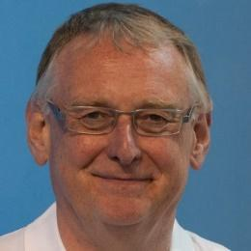
Paul Porteous (NPC)
Paul is the former CEO of the CBAI, a position he held for the best part of thirty years. Since retirement, he has enjoyed travelling and working on his garden, but continues to be very involved in the Irish bridge scene. Paul has represented Ireland on Junior (long, long ago!) and Mixed Teams at European events, and two years ago made his first Senior international appearance in the Teltscher Trophy. He will repeat that in the Irish Senior team for the European Championships in Riga in the summer. Paul is an experienced NPC, having performed that role on Lady Milne and Irish Women’s Teams at European level and with both Open & Senior teams at home internationals.

NIBU
Norma Irwin & Kathleen Cassidy
Toni Sproule & Christine Stewart
Margaret Farren and Anna Carr

Norma Irwin and Kathleen Cassidy
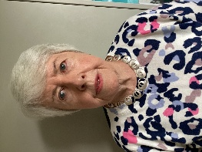
Norma taught mathematics and physics then when she retired promptly started to teach bridge! She had 3 adult classes each week covering a range of levels. She then worked with Schools’ bridge for several years, introducing the game to 11-year-olds. She now spends a lot of time travelling, having just returned from New Zealand where she played bridge in several competitions. Her latest
interests include Backgammon and playing the ukulele! She looks forward to the LM weekend, renewing friendships and meeting some new opponents.
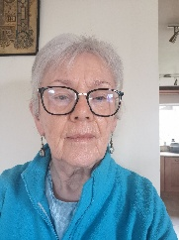
Kathleen is originally from Achill Island, County Mayo but has lived most of her adult life in Belfast. She has long retired from teaching Irish in a large Co-ed Grammar School in Belfast. This is her second time playing in the Lady Milne. She has played in many Interprovincial competitions, as an Intermediate and Area Master. Apart from bridge she enjoys sudoku, scrabble, cooking, music and spending time with family. Having recently been gifted scrabble in Irish she is looking for willing opponents to play against.

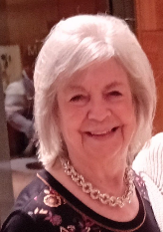
Toni Sproule and Christine Stewart
Toni is delighted to make up a home team in this year’s LM partnering
Christine for the first time. Bridge has been part of my life now for more years than she cares to remember and despite the serious consequences following the pandemic a few years ago when play was wholly online, she continues to enjoy every game played. She hopes one of these days, (sooner rather than later) to improve.

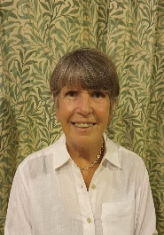
Christine is a retired teacher originally from Swansea, Wales but moved to Northern Ireland 34 years ago after the birth of my first son. I took up Bridge after retirement and have played for Ulster in the interprovincials but this is my first Lady Milne. Besides bridge, She loves travelling, various sports including tennis, pickle ball and sailing and also enjoys the theatre and dancing.

Margaret Farren and Anna Carr
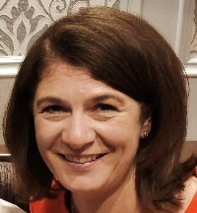
Margaret returned to bridge during covid after a considerable break. She comes from a card playing family (every game except bridge) and remembers many nights looking over her mother’s shoulder longing to be in the middle of the action. She was introduced to bridge by her local bridge club and appreciates all the volunteers who supported the club by giving lessons. When not playing cards she works in the Civil Service. She is looking forward to playing in the Lady Milne.

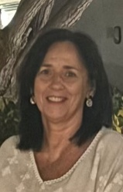
Anna is a Clinical Nurse Specialist with the Mental Health Services.
She comes from a family background in bridge, with both parents having been active players. Following her partner Margaret’s return to the game after the Covid period, they have travelled extensively to compete in competitions. She is delighted to have the opportunity to play in the Lady Milne and is very much looking forward to it.

Alan Hill NPC
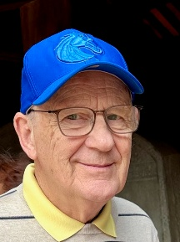
Alan, a retired University Lecturer, has been NPC of the Lady Milne team several times in the last few years. He thought he had retired but has returned this year with the NIBU team. However, his association with Home Internationals goes back many years to the days of ‘Referees’ and he has much experience over the years as a TD (gaining a grade B at the EBL TD course in Antalya). He was Jt. Hon. Sec. of the IBU for several years and has been President of both the NIBU and the IBU. He enjoys reading – mostly thrillers – gardening and watching cricket, rugby and when visiting his daughter in Boise
Idaho the Boise State Broncos American College football team.

 | Scotland  Liz McGowan & Fiona McQuaker  Sheila Adamson & Abi Milne  Sam Punch & Jen Middleton  NPC Alan Goodman

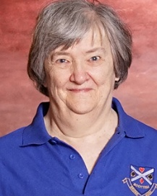
Liz McGowan & Fiona McQuaker
Liz is Scotland's only World and European Grand Master, thanks to a purple patch when she played for Great Britain before the home nations were granted separate status. She won two European Women's Championships playing with Heather Dhondy; and the inaugural World Transnational Teams playing with some great Icelanders she and Heather picked up in the bar.
She has also won 2 silver medals at World Team Olympiads playing with Sandra Penfold. She has played in a record 38 Lady Milnes, winning 11 of them, also 7 Camrose series and 6 Teltscher Trophies, winning two. Liz is a bridge teacher and journalist, heavily involved with bridge administration in Scotland and she is currently the SBU representative on BGB.

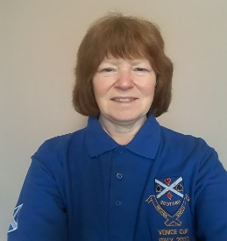
Fiona has played for Scotland in the women’s team on many occasions, and this will be her 22nd Lady Milne, winning on 6 occasions. She has played in the Scottish women’s team in seven European Championships, and four Olympiads/World Games. With several others in this team she reached the semi-final of the World Games in Wroclaw in 2016 and the Venice Cup in Wuhan in 2019. She returned to face-to-face bridge after 2 years, at the SBU Peebles congress teams in March 2022, and this was quickly followed by another Scottish cap at the Venice Cup in Salsomaggiore for which the team had only three weeks’ notice; they nevertheless produced a top half finish. She is a chartered accountant working in Edinburgh, and enjoys travelling, theatre going and walking, and is also displaying considerable skills at fantasy football.

Sheila Adamson & Abi Milne
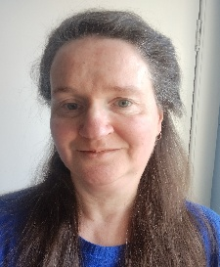
Sheila has been a frequent member of the Scottish Women’s Team since 2004, originally playing with Anne Symons and more recently Abi Milne. In that time she has won six Lady Milne events. She has also played in 8 European Championships and World Bridge Games. Sheila’s job involves quality assurance in transnational education, which means working with very nice people and attending a lot of committees. She used to spend a lot of time in airports; now she spends a lot of time on Microsoft Teams.

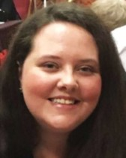
Abi is a recent addition to the Ladies' scene, having left the ranks of the Juniors in 2018 in an attempt to emulate the better known members of the Scotland Ladies ranks. As it so happened, she managed to do so at the first attempt with her current partner Sheila, and was therefore part of the winning Lady Milne team on her debut. At that time she was still playing under her maiden name, so celebrated shortly after by adopting the Milne name by marrying Jake. Abi has a very good temperament for the game, so don’t try to ruffle her at the table. You will just be wasting your time!
Abi is a systems analyst by day, keen writer by night and now an accomplished bridge player in the space between.

Brian Short (NPC)

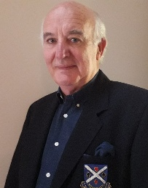
Brian played bridge for Great Britain with long-time partner Sandy Duncan on 3 occasions before Scotland got international autonomy, winning Bronze in the 1977 Common Market championships. He has played in 55 Camrose weekends with five different partners, winning on three occasions. He has also played 7 times in the senior Camrose and has made multiple European and Olympiad appearances in Open, Senior and Mixed events.

He has captained or coached the Scottish womens’ team on 16 occasions. At least he thinks it is 16. “My mind is a bit numb now”, he explained recently, declining to offer a view on why it was numb. He won the Gold Cup in 2006 and has multiple wins in every major Scottish event, including Scotland’s premier teams’ competition (the Scottish Cup) which he has won on 15 occasions. Two sons, a daughter and six grandchildren keep him busy and as elder son lives in Melbourne and younger son in Switzerland, Kate and he have plenty of excuse to travel.

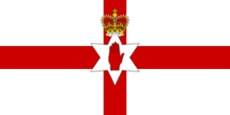 | Northern Ireland  Anne Fitzpatrick & Mary Kelly-Rogers  Sandie Millership & Anne Hassan  Diane Greenwood & Nuala Mooney  NPC Harold Curran

Anne Fitzpatrick
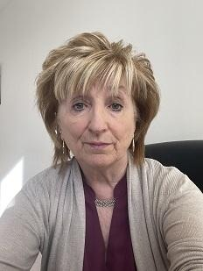
Anne is a retired accountant living in Belfast and is currently Treasurer for both NIBU and IBU. She is looking forward to her seventh time playing with Mary in the Lady Milne. She has previously played in the Teltscher with Harold Curan and also represented Ireland with Mary in Beunos Aires in the World Championships 2024. When not playing bridge she enjoys spending time with her children and grandchildren , line dancing and travelling.

Mary Kelly-Rogers
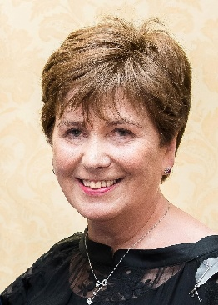
Mary, having instigated the idea of a Women’s Bridge Coordinator (WBC) within the concept of Women’s Bridge for the European Bridge League(EBL), is actively bringing this concept to the World Bridge Federation (WBF) as vice chair of the WBF Women’s Committee. The purpose is to inform, encourage, develop and network Women’s Bridge with the WBC in each NBO in the world at the helm. There is a goal, it’s working and this concept was first presented to the Officers at the EBL Officers’ Seminar in Belfast in 2018! It’s back to Belfast now for Lady Milne. Online Championships was also her idea; she presented the idea to the late WBF President Jan Kamras. The inaugural WBF Online Women's Teams on RealBridge in 2024 was the stepping stone for other categories to follow and by the time we play the 2026 Lady Milne there will be a winner of the 3rd WBF Women’s Online. A Lady Milne team hopefully!The Lady Milne is at the heart and forefront of a Women’s championships and Mary is looking forward to playing with this Lady Milne NIBU team under the captaincy of Heather Hill, meeting women players from the five Federations, some who are now friends and is delighted to have the opportunity to play again with one of her very best friends, Anne Fitzpatrick, believing that friendship through competition really does work!

Sandie Millership
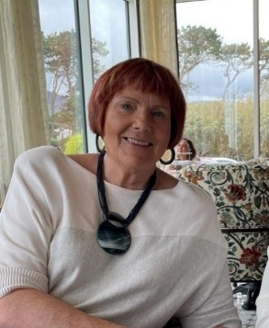
Sandie is a retired Pharmacist living in Bangor with her cat , Smokey.
She has been involved in Junior bridge for more years than she cares to remember. She loves watching the youngster’s enthusiasm for the game but also gives thanks for permanent hair colours which disguise the grey hair which watching them produces.
She has captained the Junior Camrose & Peggy Bayer teams many times and also captained the Lady Milne team on a number of occasions and also the Teltscher team 3 years ago. She only needs to captain the Camrose team for a full house, hint, hint! She also played in the inaugural Senior Camrose with her late husband, Jeff (yes, she is that old 😊).

Anne Hassan
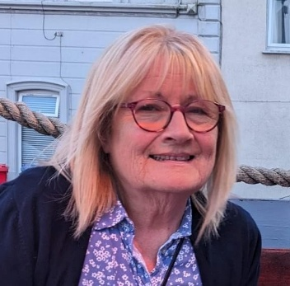
Anne is a retired teacher and mother to four children and ten grandchildren and has enjoyed bridge at club and local competition level for many years. This is her fourth time to participate in the Lady Milne event. Most of her bridge years were dedicated to the administrative and organisational side of game – holding posts of Secretary, Chair and Congress Organiser of the NIBU, and recently teaching bridge in primary schools. Anne is passionate about bridge and its ability to change the lives of the people who have discovered and enjoy it especially at club level. Other hobbies include watercolour painting, gardening and a wee glass of wine!
Diane Greenwood
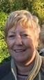
Diane learnt to play bridge at grammar school in Northern Ireland and has represented Ireland at Ladies International level on many occasions. She has also represented Northern Ireland in the Home International Series many times - probably with over 50 different partners in all of these tournaments.
She has had many interesting jobs including working for 21 years in Ulster Television, water surveyor, teaching in South Africa, volunteering in a chimpanzee sanctuary in Zambia and also working as a penguin policeman (guarding penguins) on one of the many cruises she has worked on for Mr Bridge/BMB.

Nuala Mooney
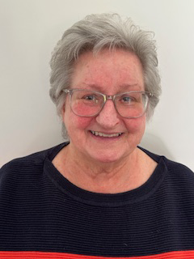
Nuala has played bridge for a number of years and is a founder member of Derryvolgie bridge club the biggest in Northern Ireland.
She has recently retired from teaching beginners bridge leaving some disappointed would be players behind.
Nuala still likes playing poker but since covid not too much poker to be played. She has 4 children and 9 grandchildren and is very happy to help with them.
N.P.C. Heather Hill
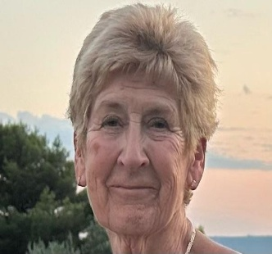
Heather is a retired Maths teacher who still works for her local exam board both as reviser and team leader for A level maths. Her other interests include travel - to Boise Idaho and Newcastle upon Tyne to spend time with grandchildren, cruising and city breaks in Europe. Recent visits to India ,Vietnam and Cambodia have been most enjoyable. She also enjoys walking, yoga and doing cryptic crosswords. She has played in both the Lady Milne and Teltscher a number of times This is the first time she has acted as NPC having had her ‘arm twisted’ by a very persuasive Chair of selectors.

 | Wales  Sophie Cunningham & Ceri Pierce  Suzi Lawson & Gilly Clench  Sue Ingham & Mia Deschepper NPC Paul Lamford

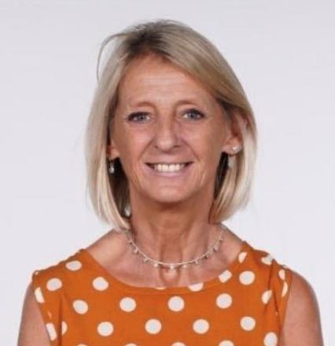
Sophie Cunningham and Ceri Pierce
This is Sophie’s first time playing in the Lady Milne, with Ceri. Sophie learnt bridge as a teenager from her father but work and having her daughter, meant competitive bridge took a back seat for many years. With the encouragement of Ceri Pierce and Laura Woodruff, Sophie has been back playing competitive bridge for the last 4 years and is loving it as much as she always did.

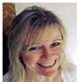
Ceri was horrified to realise at the weekend that she had been playing bridge for over 30 years (although that did include a 15-year break). She had not realised how old she was. She has played in numerous Lady Milne events since the 90s, this being her first with Sophie. Ceri is an IT consultant for a well-known company in Belfast, lives in Somerset (but is actually Welsh) and has three grown up children, Nick, Pete and Abbie who have all now flown her nest but come back from time to time with huge bags of washing. When not playing bridge she can usually be found in an Indian restaurant.

Suzy Lawson and Gilly Clench
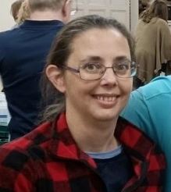
This is their third Lady Milne playing together – something must be okay. ☺ They had a great time in their first European competition together last year in the wonderful Polish city of Poznan. What do they remember? The slides in the water park probably….
Suzy likes social bridge - flying off to the Mutton Cup, Llanbrighton and various other fun Congresses. She still sits like a hobbit, almost on her hair and her other bad habit, apart from playing with Gilly, is to have a quiet rollie braving the cold outside. She is just recovering from an awfully big adventure in New Zealand, so don’t expect too much.

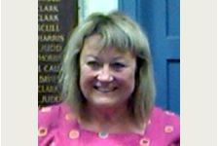
Gilly is also recovering from two skiing trips, so don’t expect too much. Someone counted her many appearances at the Lady Milne but she hasn’t and will probably never catch up with Liz McGowan. She is still as loud as her clothes, which don’t seem to fit these days. She is enjoying life at many Summer schools and workshops making useless items which clutter the house – and cycling. Lush, as they say in Wales. Does anyone read these?

Sue Ingham and Mia Deschepper
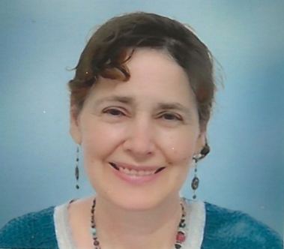
Sue has been playing bridge for nearly forty years. This is her ninth Lady Milne, and she was a member of the winning team in 2015. This is her first Lady Milne in partnership with Mia, having seen off five previous partners. She has also played in four Camrose weekends with her male partner Gwynn. She lives in Cardiff with Gwynn and their cat Freddie. She works part-time for Social Security Tribunals. Any time left over after work and bridge is spent reading murder mystery novels, doing puzzles and watching rubbish on television.

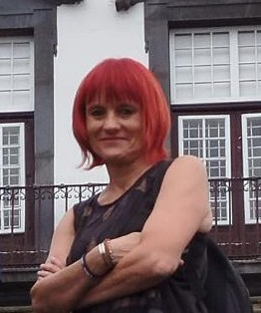
Mia started playing bridge 10 years ago and was quickly hooked. She was lucky to find much better players to help her improve. She has represented Wales in the last six LMs with Ceri Pierce and, this year, she will try her luck with Sue Ingham. She also played in the Camrose and International Mixed Teams events with Adrian Thomas, Richard Plackett and Tim Rees, including winning the inaugural British Isles Trophy. Away from the bridge table, Mia loves reading, hiking and learning something new.

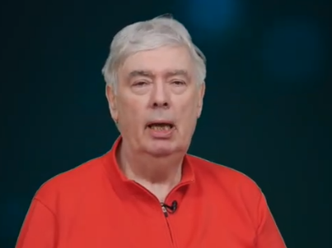
Paul Lamford (NPC)
Paul, originally from Carmarthen, played chess for many years, including in four Olympiads. Bridge successes have been few, the Chairman’s Cup in Sweden (2014) being the most prestigious. More recently Paul has played with Gary Jones; they were top pair in the 2020 Camrose, won the Teltscher in 2025 and have played for Wales in the last three Europeans with decreasing success. They play in the Welsh Online league and have won this seven times, with teammates John Salisbury, Mike Tedd, Julian Pottage and Tony Ratcliff, with whom they have also won the Welsh Premier League.and Welsh Cup.
IMPS | VPs |  | IMPS | VPs |  | IMPS | VPs
0 | 10.00- 10.00 |  | 29 | 15.10-4.90 |  | 58 | 18.21 -1.79
1 | 10.22 - 9.78 |  | 30 | 15.24-4.76 |  | 59 | 18.29 -1.71
2 | 10.44 - 9.56 |  | 31 | 15.37 -4.63 |  | 60 | 18.37 -1.63
3 | 10.65- 9.35 |  | 32 | 15.50-4.50 |  | 61 | 18.45-1.55
4 | 10.86-9.14 |  | 33 | 15.63-4.37 |  | 62 | 18.53-1.47
5 | 11.07 -8.93 |  | 34 | 15.76-4.24 |  | 63 | 18.61 -1.39
6 | 11.27 - 8.73 |  | 35 | 15.88-4.12 |  | 64 | 18.69 -1.31
7 | 11.47 -8.53 |  | 36 | 16.00 - 4.00 |  | 65 | 18.76 -1.24
8 | 11.67 - 8.33 |  | 37 | 16.12- 3.88 |  | 66 | 18.83 - 1.17
9 | 11.86-8.14 |  | 38 | 16.24 - 3.76 |  | 67 | 18.90-1.10
10 | 12.05-7.95 |  | 39 | 16.35 - 3.65 |  | 68 | 18.97-1.03
11 | 12.24- 7.76 |  | 40 | 16.46 - 3.54 |  | 69 | 19.04 - 0.96
12 | 12.42- 7.58 |  | 41 | 16.57 - 3.43 |  | 70 | 19.11 -0.89
13 | 12.60- 7.40 |  | 42 | 16.68- 3.32 |  | 71 | 19.18 - 0.82
14 | 12.78- 7.22 |  | 43 | 16.79 - 3.21 |  | 72 | 19.25- 0.75
15 | 12.95-7.05 |  | 44 | 16.90-3.10 |  | 73 | 19.32 - 0.68
16 | 13.12-6.88 |  | 45 | 17.01 - 2.99 |  | 74 | 19.38- 0.62
17 | 13.29 - 6.71 |  | 46 | 17.11 - 2.89 |  | 75 | 19.44 - 0.56
18 | 13.46 - 6.54 |  | 47 | 17.21 - 2.79 |  | 76 | 19.50- 0.50
19 | 13.62 - 6.38 |  | 48 | 17.31 - 2.69 |  | 77 | 19.56 - 0.44
20 | 13.78 - 6.22 |  | 49 | 17.41 - 2.59 |  | 78 | 19.62 - 0.38
21 | 13.94 - 6.06 |  | 50 | 17.51 - 2.49 |  | 79 | 19.68- 0.32
22 | 14.09 - 5.91 |  | 51 | 17.60- 2.40 |  | 80 | 19.74 - 0.26
23 | 14.24 - 5.76 |  | 52 | 17.69- 2.31 |  | 81 | 19.80- 0.20
24 | 14.39 - 5.61 |  | 53 | 17.78- 2.22 |  | 82 | 19.85-0.15
25 | 14.54 - 5.46 |  | 54 | 17.87 - 2.13 |  | 83 | 19.90-0.10
26 | 14.68- 5.32 |  | 55 | 17.96- 2.04 |  | 84 | 19.95 - 0.05
27 | 14.82 - 5.18 |  | 56 | 18.05 - 1.95
28 | 14.96 - 5.04 |  | 57 | 18.13-1.87

VP SCALE (32 BOARDS)

International Match Point Scale

Points difference |  |  | IMPs |  |  | Points difference |  |  | IMPs
0 | - | 10 | = | 0 |  | 750 | - | 890 | = | 13
20 | - | 40 | = | 1 |  | 900 | - | 1090 | = | 14
50 | - | 80 | = | 2 |  | 1100 | - | 1290 | = | 15
90 | - | 120 | = | 3 |  | 1300 | - | 1490 | = | 16
130 | - | 160 | = | 4 |  | 1500 | - | 1740 | = | 17
170 | - | 210 | = | 5 |  | 1750 | - | 1990 | = | 18
220 | - | 260 | = | 6 |  | 2000 | - | 2240 | = | 19
270 | - | 310 | = | 7 |  | 2250 | - | 2490 | = | 20
320 | - | 360 | = | 8 |  | 2500 | - | 2990 | = | 21
370 | - | 420 | = | 9 |  | 3000 | - | 3490 | = | 22
430 | - | 490 | = | 10 |  | 3500 | - | 3990 | = | 23
500 | - | 590 | = | 11 |  | 4000 and above |  |  | = | 24
600 | - | 740 | = | 12

